24CSIS03C
Database 1



Module Leader Dr Doaa Elzanfaly
TA: Manar
Blood Bank Management System

Scope of the Blood Bank Management System:
The scope of our blood bank management system is about the process of donating blood.
Description:
The blood management system database is used to manage, store, and collect data about blood donation, inventory management, and patient data. By managing blood supply, donor data, and patient transfusion requirements, the system seeks to improve the effectiveness of blood banks, hospitals, and any organization associated with managing blood banks. The Blood Bank entity is at the centre of this system, managing all aspects of operations, including donor relations and blood product inventory. Essential details about each blood donor are recorded in the Donor table, and each donation event is linked to the appropriate donor in the Donation table. Through the Blood Inventory, which keeps track of available types and amounts of blood, these donations help the blood bank effectively meet hospital demands. The Storage Facility table lists blood locations and storage conditions, which are essential for preserving the blood products' quality. The Blood Request entity, which monitors requests for blood kinds and volumes, is another way that the system links hospitals to blood supply needs. Furthermore, the Patient and Transfusion Event tables provide accurate tracking of patients requiring transfusions by recording their transfusion history and related blood types. To ascertain donor eligibility and guarantee the security of blood transfusions, the Medical History table is essential, while the Employee table keeps track of staff who work on the operations. All of these elements work together to create a thorough framework that improves coordination and communication, which eventually leads to better patient outcomes and increased operational effectiveness throughout the blood bank system. The approach aims to maintain the highest standards of safety and quality in blood transfusions while also streamlining operational procedures by combining data from each of these entities.
Tables:
- Donor
- Donation
- Blood Bank
- Blood Inventory
- Storage Facility
- Hospital
- Patient History
- Donor history
- Employee
- Patient
- Transfusion Event
- Blood Request
- Makes (Junction table)
- Phone numbers
- Nurse
- Doctor

Subclasess:
- Disjoint from Medical History:
- Patient_History
- Donor_History: Last_Donation_Date (DATE)

- Disjoint from Employee:
- IT_Support_Specialist: Technical_Proficiency (VARCHAR)
- Nurse: Certification_Type (VARCHAR)
- Doctor: Specialisation (VARCHAR)
- Secretary: Typing_Speed (VARCHAR)

- Disjoint from Employee:
- Salaried_Emp: Salary (DECIMAL)
- Hourly_Emp: Pay_Scale (DECIMAL)
Relations:
- Donor and donation:M-N
Many donors can make many donations.
- Blood bank and donation: 1-N
The blood bank can receive multiple donations, and each donation record is linked to one specific blood bank. The relation is obligatory from both sides.
- Storage facility and Blood inventory: 1-N
Each storage facility contains many blood inventories, and many inventories are stored in one facility. The relation is mandatory from the blood inventory side.
- Blood inventory and Donation: 1-N
Each inventory contains many blood donations, and many donations are stored in one inventory. The relation is mandatory from the blood inventory side as blood donations can be only stored in inventories.
- Blood Bank and Hospital: 1-N
Our blood bank system cooperates with many hospitals, and many hospitals work with our blood bank. The relation is mandatory from the hospital side.
- Donor history and Donor: 1 - 1
One donor has only one corresponding record in the donor history table, and each donation history is only associated with one donor. The relation is mandatory from both sides.
- Patient and Patient history: 1 - 1
Each patient is associated with one single record in the patient history table and vice versa. The relation is mandatory from both sides.
- Patient and Transfusion event: 1-N
One patient can have multiple transfusion events, and each transfusion can is associated with only one patient. The relation is mandatory form the transfusion event.

- Patient and Blood request
Each patient can have multiple requests for blood, and one blood request is only directed to one patient.
Patient 1N Blood request
Blood Request 11 Patient
Therefore, the final relation is 1-N.
It is mandatory for both sides.
- Blood bank and Patient: 1-N
The blood bank provides blood units to multiple patients, and many patients get blood units from our blood bank. The relation is mandatory from the patient side.
- Blood bank and Employee:1-N
The blood bank has many employees, and employees work only in the blood bank. The relationship is mandatory for both sides.
Functionalities:
- Managing the blood inventory:
- Showing the current stock of each blood type with its storing date to ensure it’s not expired.
- Extracting the blood units that are about to expire to prioritize the usage.
- Managing the Donations and Donors Data:
- Viewing the history for a specific donor, helping track frequency and quantity of donations.
- Extracting the donors eligible for new donations based on last donation date.
- Medical and Compliance Functions:
- Generating a report for the patient’s medical history and provide insights into past treatments and conditions.
- Monitoring the most demanded blood types by tracking requests over the past month will help in planning for future inventory needs.
- Employee and Facility Management:
- Providing a history of transfusions performed by a specific employee, useful for performance tracking.
- Compares current inventory levels to storage facility capacity, ensuring facilities are not overstocked.
- Find Donors with Rare Blood Types:
- Identifying donors with rare blood types will maintain adequate inventory of high-demand and scarce blood types.
- Request and Supply Chain Management:
- Analysing Blood Requests by Hospital by tracking requested volume from each hospital by blood type and identifying high-demand facilities for better supply planning.
- Detailed Donor Engagement Analysis:
- Showing the total number of donations and volume for each donor helps recognizing high-contributing donors.

EERD:
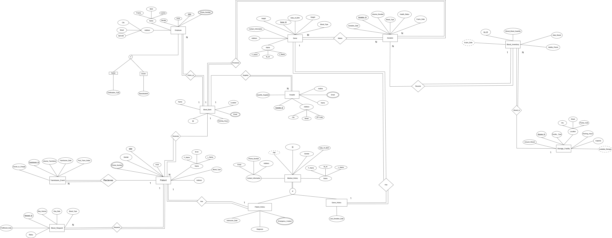

P.S. Zoom in for better view

Final Schema:
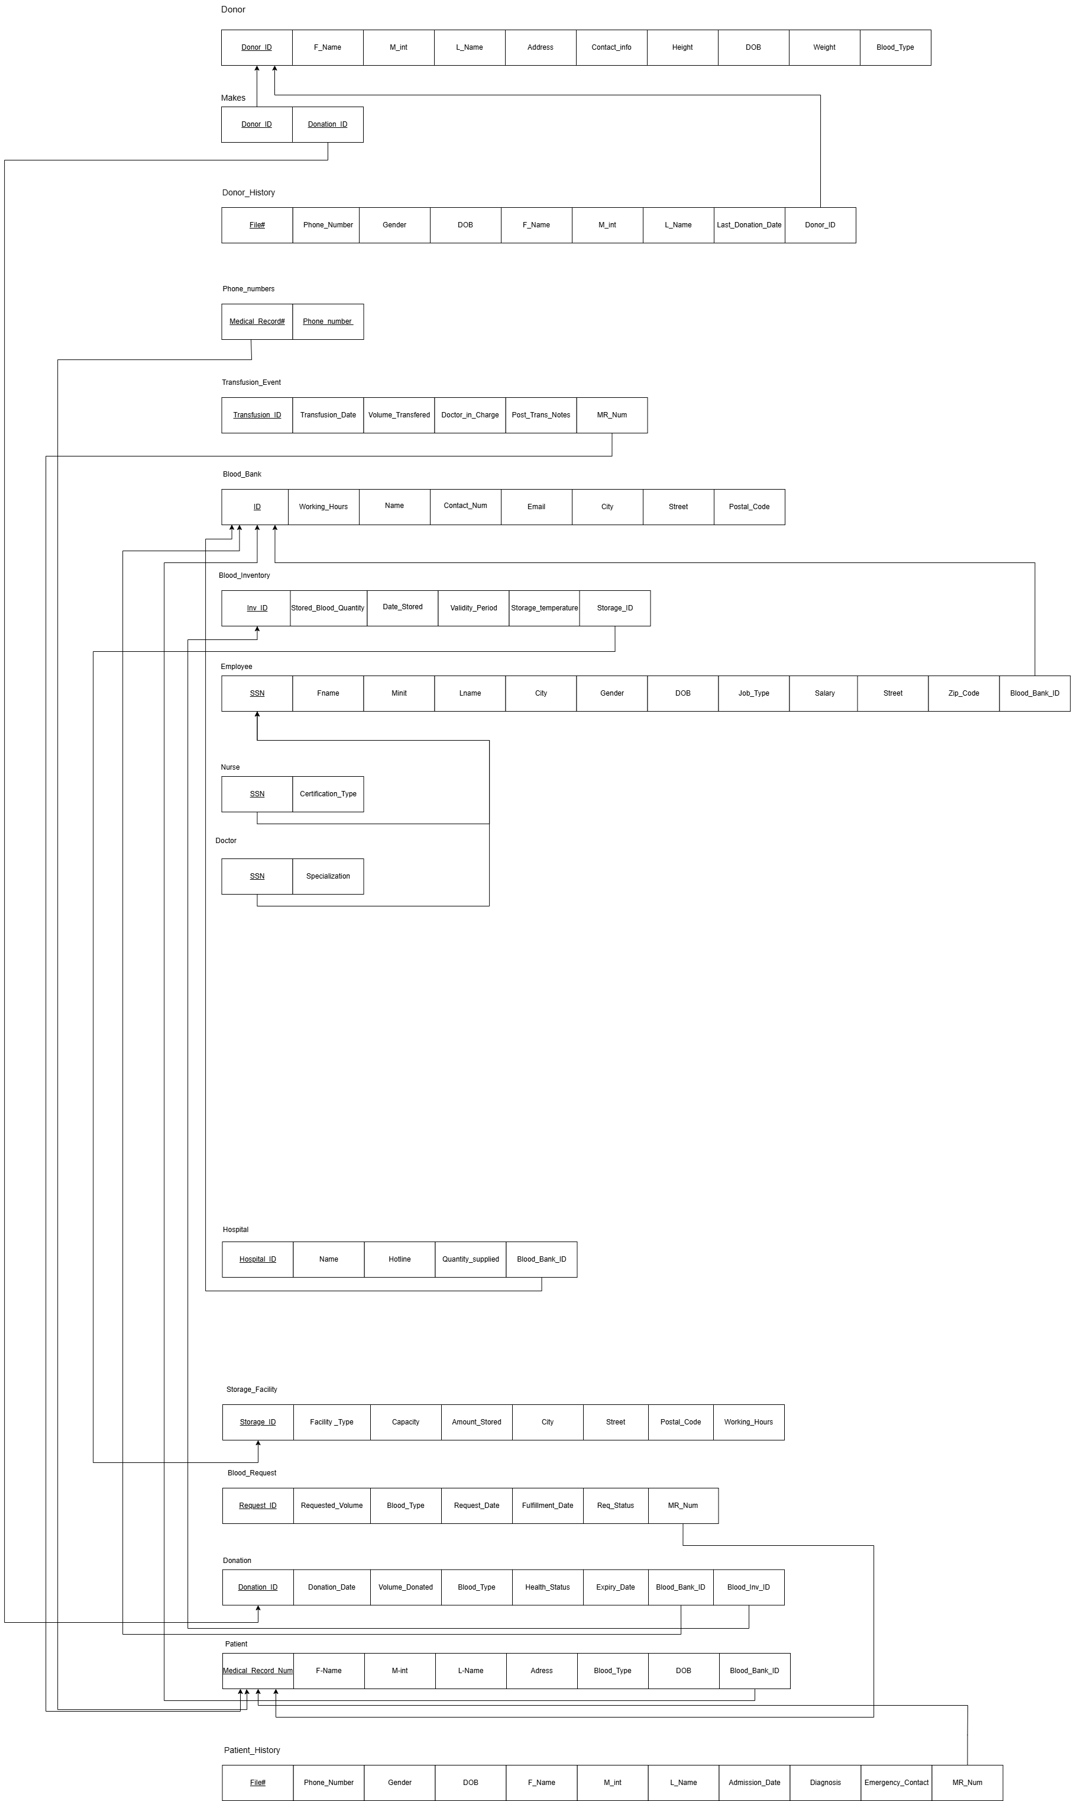

P.S. Zoom in for better view

SQL Code:
CREATE DATABASE Blood_Bank_Management_4;
/*omayr ali 242994*/
CREATE TABLE Blood_Bank (
ID INT,
Bank_Name VARCHAR(50) NOT NULL,
Email VARCHAR(50),
City VARCHAR(20),
Street VARCHAR(50),
Postal_Code VARCHAR(10),
Working_Hours VARCHAR(10),
Contact_Number VARCHAR(20) NOT NULL,
CONSTRAINT bank_pk PRIMARY KEY (ID)
);
/*omayr ali 242994*/

/*ebrahim gamal 241939*/
CREATE TABLE Storage_Facility (
Storage_ID INT NOT NULL,
Facility_Type VARCHAR(80),
Capacity DECIMAL,
Working_hours VARCHAR(60),
City VARCHAR(40),
Street VARCHAR(40),
Postal_Code VARCHAR(100),
CONSTRAINT Storage_Facility_PK PRIMARY KEY (Storage_ID)
);
/*ebrahim gamal 241939*/

/*sohaila taher*/
CREATE TABLE Donor (
Donor_ID INT,
Fname VARCHAR(20),
M_int VARCHAR(20),
Lname VARCHAR(20),
Address VARCHAR(100),
Contact_Info VARCHAR(100),
Height DECIMAL,
Date_of_Birth DATE,
Weight DECIMAL,
Blood_Type CHAR(3),
CONSTRAINT Donor_pk PRIMARY KEY (Donor_ID)
);
/*sohaila taher*/

/*sohaila taher 245365*/
CREATE TABLE Donor_History (
File_Number VARCHAR(50),
Phone_Number VARCHAR(50),
Gender CHAR(1),
Date_of_Birth DATE,
Fname VARCHAR(50),
M_int VARCHAR(50),
Lname VARCHAR(50),
Last_Donation_Date DATE,
Donor_ID INT,
CONSTRAINT Donor_History_pk PRIMARY KEY (File_Number),
CONSTRAINT History_Donor FOREIGN KEY (Donor_ID) REFERENCES Donor(Donor_ID)
ON UPDATE CASCADE
ON DELETE SET NULL
);
/*sohaila taher 245365*/

/*shahd osama 247915*/
CREATE TABLE Employee (
Fname VARCHAR(20) NOT NULL,
Minit CHAR(10),
Lname VARCHAR(20) NOT NULL,
Ssn INT NOT NULL,
BOD DATE,
City VARCHAR(20) NOT NULL,
Street VARCHAR(20) NOT NULL,
Zip_code INT,
Gender CHAR(1),
Blood_Bank_ID INT,
CONSTRAINT emp_pk PRIMARY KEY (Ssn),
CONSTRAINT BloodBank_Emp FOREIGN KEY (Blood_Bank_ID) REFERENCES Blood_Bank(ID)
);

CREATE TABLE Nurse (
Ssn INT NOT NULL,
Certification_type VARCHAR(35) NOT NULL,
CONSTRAINT Nurse_pk PRIMARY KEY (Ssn),
CONSTRAINT Emp_Nurse FOREIGN KEY (Ssn) REFERENCES Employee(Ssn)
);

CREATE TABLE Doctor (
Ssn INT NOT NULL,
Specialization VARCHAR(35) NOT NULL,
CONSTRAINT Doctor_pk PRIMARY KEY (Ssn),
CONSTRAINT Emp_Doctor FOREIGN KEY (Ssn) REFERENCES Employee(Ssn)
);

CREATE TABLE Hospital (
Hospital_id INT NOT NULL,
Name VARCHAR(35) NOT NULL,
City VARCHAR(20) NOT NULL,
Street VARCHAR(20) NOT NULL,
Zip_code INT,
Hotline INT NOT NULL,
Email VARCHAR(100),
Quantity_supplied INT,
Blood_Bank_ID INT,
CONSTRAINT Hospital_pk PRIMARY KEY (Hospital_ID),
CONSTRAINT Hosp_Bank FOREIGN KEY (Blood_Bank_ID) REFERENCES Blood_Bank(ID)
);
/*shahd osama 247915*/

/*omayr ali 242994*/
CREATE TABLE Blood_Inventory (
Inv_ID INT,
Stored_Blood_Quantity DECIMAL NOT NULL,
Date_Stored DATE,
Validity_Period INT NOT NULL, -- days
Storage_Temperature VARCHAR(10),
Storage_ID INT,
CONSTRAINT inv_pk PRIMARY KEY (Inv_ID),
CONSTRAINT inv_storage_fk FOREIGN KEY (Storage_ID) REFERENCES Storage_Facility(Storage_ID)
ON UPDATE CASCADE
);
/*omayr ali 242994*/

/*abdelrahman shehta 243700*/
CREATE TABLE Patient (
Medical_Record_Num INT NOT NULL,
Fname VARCHAR(20) NOT NULL,
Mint VARCHAR(20) NOT NULL,
Lname VARCHAR(20) NOT NULL,
DOB DATE,
Gender CHAR(1),
Address VARCHAR(300),
Blood_type CHAR(3),
Blood_Bank_ID INT,
CONSTRAINT Pat_pk PRIMARY KEY (Medical_Record_Num),
CONSTRAINT pat_fk1 FOREIGN KEY (Blood_Bank_ID) REFERENCES Blood_Bank(ID)
ON UPDATE CASCADE
ON DELETE SET NULL
);
/*abdelrahman shehta 243700*/

/*sohaila taher*/
CREATE TABLE Patient_History (
File_Number VARCHAR(30),
Phone_Number VARCHAR(30),
Gender CHAR(1),
Date_of_Birth DATE,
Fname VARCHAR(30),
M_int VARCHAR(30),
Lname VARCHAR(30),
Admission_Date DATE,
Diagnosis VARCHAR(30),
Medical_Record_Number INT,
CONSTRAINT Patient_History_pk PRIMARY KEY (File_Number),
CONSTRAINT History_Patient FOREIGN KEY (Medical_Record_Number) REFERENCES Patient(Medical_Record_Num)
);
/*sohaila taher*/

/*omayr ali 242994*/
CREATE TABLE Blood_Request (
Request_ID INT,
Requested_Volume DECIMAL NOT NULL, -- litres
Blood_Type CHAR(3) NOT NULL,
Request_Date DATE,
Fulfillment_Date DATE,
Req_Status VARCHAR(15), -- Pending - Fulfilled
MR_Num INT,
CONSTRAINT req_pk PRIMARY KEY (Request_ID),
CONSTRAINT req_patient_fk FOREIGN KEY (MR_Num) REFERENCES Patient(Medical_Record_Num)
ON UPDATE CASCADE
ON DELETE SET NULL
);
/*omayr ali 242994*/

/*ebrahim gamal 241939*/
CREATE TABLE Transfusion_Event (
Transfusion_ID INT NOT NULL,
Transfusion_Date DATE,
Volume_Transfered_litres DECIMAL,
Doctor_in_Charge VARCHAR(50),
Post_Trans_Notes VARCHAR(500),
Medical_Record_Num INT NOT NULL,
CONSTRAINT Trans_Event_Pk PRIMARY KEY (Transfusion_ID),
CONSTRAINT Trans_Event_FK FOREIGN KEY (Medical_Record_Num) REFERENCES Patient(Medical_Record_Num)
ON UPDATE CASCADE
);
/*ebrahim gamal 241939*/

/*abdelrahman shehta 243700*/
CREATE TABLE Donation (
Donation_ID INT NOT NULL,
Volume_Donated DECIMAL,
Blood_Type CHAR(3),
Health_Status VARCHAR(30),
Expiry_Date DATE,
Donation_Date DATE,
Blood_Bank_ID INT,
Inv_ID INT,
CONSTRAINT Don_pk PRIMARY KEY (Donation_ID),
CONSTRAINT don_fk1 FOREIGN KEY (Blood_Bank_ID) REFERENCES Blood_Bank(ID),
CONSTRAINT don_fk2 FOREIGN KEY (Inv_ID) REFERENCES Blood_Inventory(Inv_ID)
);

CREATE TABLE Phone_numbers (
MR_Num INT,
Phone_Number VARCHAR(30),
CONSTRAINT Phone_pk PRIMARY KEY (Phone_Number),
CONSTRAINT Phone_fk FOREIGN KEY (MR_Num) REFERENCES Patient(Medical_Record_Num)
);
/*abdelrahman shehta 243700*/

/*ebrahim gamal 241939*/
CREATE TABLE Makes (
Donor_ID INT,
Donation_ID INT,
CONSTRAINT Makes_pk PRIMARY KEY (Donor_ID, Donation_ID),
CONSTRAINT Makes_fk1 FOREIGN KEY (Donor_ID) REFERENCES Donor(Donor_ID),
CONSTRAINT Makes_fk2 FOREIGN KEY (Donation_ID) REFERENCES Donation(Donation_ID)
);
/*ebrahim gamal 241939*/

ALTER TABLE Employee
ADD IsMarried CHAR;

ALTER TABLE Employee
DROP COLUMN IsMarried;

INSERT INTO Blood_Bank
VALUES
(10001, 'Central Blood Bank', 'central@bloodbank.com', 'Cairo', 'Nasr City St.', '12345', '9AM-5PM', '+201001234567'),
(10002, 'Alex Blood Bank', 'alex@bloodbank.com', 'Alexandria', 'Corniche Rd.', '54321', '8AM-4PM', '+201142345678'),
(10003, 'Delta Blood Bank', 'delta@bloodbank.com', 'Tanta', 'Al Gharbeya St.', '67890', '10AM-6PM', '+201203456789'),
(10004, 'Aswan Blood Bank', 'aswan@bloodbank.com', 'Aswan', 'Nile Corniche', '13579', '7AM-3PM', '+201004567890'),
(10005, 'Giza Blood Bank', 'giza@bloodbank.com', 'Giza', 'Pyramids Rd.', '24680', '11AM-7PM', '+201105678901'),
(10006, 'Port Said Blood Bank', 'portsaidbank@gmail.com', 'Port Said', 'Freedom Rd.', '11111', '8AM-4PM', '+201011234567'),
(10007, 'Mansoura Blood Bank', 'mansourabank@outlook.com', 'Mansoura', 'University St.', '22222', '7AM-3PM', '+201022345678'),
(10008, 'Suez Blood Bank', 'suezbank@gmail.com', 'Suez', 'Port Rd.', '33333', '10AM-6PM', '+201033456789'),
(10009, 'Fayoum Blood Bank', 'fayoumbank@gmail.com', 'Fayoum', 'Lake Rd.', '44444', '9AM-5PM', '+201044567890'),
(10010, 'Beni Suef Blood Bank', 'benisuefbank@outlook.com', 'Beni Suef', 'Pyramids Rd.', '55555', '8AM-4PM', '+201055678901'),
(10011, 'Zagazig Blood Bank', 'zagazigbank@gmail.com', 'Zagazig', 'Al Mansoura St.', '66666', '7AM-3PM', '+201066789012'),
(10012, 'Minya Blood Bank', 'minyabank@outlook.com', 'Minya', 'Corniche St.', '77777', '10AM-6PM', '+201077890123'),
(10013, 'Qena Blood Bank', 'qenabank@gmail.com', 'Qena', 'Luxor Rd.', '88888', '8AM-4PM', '+201088901234'),
(10014, 'Sohag Blood Bank', 'sohagbank@outlook.com', 'Sohag', 'Al Mahatta Rd.', '99999', '9AM-5PM', '+201099012345'),
(10015, 'Ismailia Blood Bank', 'ismailiabank@gmail.com', 'Ismailia', 'Suez Canal Rd.', '11223', '7AM-3PM', '+201011112222'),
(10016, 'Damietta Blood Bank', 'damiettbank@outlook.com', 'Damietta', 'Corniche Rd.', '22112', '8AM-4PM', '+201022223333'),
(10017, 'Luxor Blood Bank', 'luxorbank@gmail.com', 'Luxor', 'Pharaoh St.', '33445', '10AM-6PM', '+201033334444'),
(10018, 'Asyut Blood Bank', 'asyutbank@outlook.com', 'Asyut', 'Nile Rd.', '55678', '9AM-5PM', '+201044445555'),
(10019, 'Sharm Blood Bank', 'sharmbank@gmail.com', 'Sharm El-Sheikh', 'Tourist Rd.', '66789', '8AM-4PM', '+201055556666'),
(10020, 'Hurghada Blood Bank', 'hurghadabank@outlook.com', 'Hurghada', 'Red Sea Rd.', '77890', '7AM-3PM', '+201066667777'),
(10021, 'Tanta Blood Bank', 'tantabank@gmail.com', 'Tanta', 'Al Gharbeya Rd.', '88901', '9AM-5PM', '+201077778888'),
(10022, 'Banha Blood Bank', 'banhabank@outlook.com', 'Banha', 'Delta Rd.', '99012', '10AM-6PM', '+201088889999'),
(10023, 'Matruh Blood Bank', 'matruhbank@gmail.com', 'Matruh', 'Coast Rd.', '10101', '8AM-4PM', '+201099990000'),
(10024, 'New Valley Blood Bank', 'newvalleybank@outlook.com', 'New Valley', 'Desert Rd.', '12321', '9AM-5PM', '+201011001122'),
(10025, 'North Sinai Blood Bank', 'northsinaibank@gmail.com', 'North Sinai', 'Arish Rd.', '14141', '7AM-3PM', '+201022112233');

INSERT INTO Storage_Facility VALUES
(1, 'Hospital Storage', 500.0, '8:00 AM - 8:00 PM', 'Cairo', 'Tahrir Street', '11511'),
(2, 'Blood Bank', 1000.0, '24/7', 'Alexandria', 'Corniche Road', '21523'),
(3, 'Medical Center Storage', 300.0, '9:00 AM - 5:00 PM', 'Giza', 'Pyramids Avenue', '12512'),
(4, 'Emergency Storage', 200.0, '24/7', 'Aswan', 'Nile Street', '81111'),
(5, 'Hospital Storage', 750.0, '7:00 AM - 7:00 PM', 'Mansoura', 'Port Said Street', '35516'),
(6, 'Clinic Storage', 150.0, '9:00 AM - 3:00 PM', 'Suez', 'Victory Road', '43515'),
(7, 'Blood Donation Center', 600.0, '8:00 AM - 6:00 PM', 'Tanta', 'Saad Zaghloul Street', '31512'),
(8, 'Hospital Storage', 900.0, '6:00 AM - 10:00 PM', 'Zagazig', 'Mahmoud Fawzy Street', '44511'),
(9, 'Blood Bank', 1200.0, '24/7', 'Fayoum', 'Republic Street', '63512'),
(10, 'Mobile Storage Unit', 100.0, 'Variable', 'Port Said', 'Canal Avenue', '42511'),
(11, 'Emergency Storage', 250.0, '24/7', 'Ismailia', 'Suez Canal Street', '41515'),
(12, 'Hospital Storage', 800.0, '7:00 AM - 9:00 PM', 'Luxor', 'Ramses Street', '85111'),
(13, 'Medical Center Storage', 350.0, '9:00 AM - 4:00 PM', 'Qena', 'Victory Street', '86115'),
(14, 'Clinic Storage', 200.0, '8:00 AM - 3:00 PM', 'Asyut', 'Freedom Avenue', '71111'),
(15, 'Blood Bank', 1300.0, '24/7', 'Sharm El-Sheikh', 'Peace Road', '46512'),
(16, 'Hospital Storage', 600.0, '6:00 AM - 8:00 PM', 'Dahab', 'Coastal Road', '46517'),
(17, 'Clinic Storage', 150.0, '9:00 AM - 5:00 PM', 'Qualiub', 'Nasser Street', '61112'),
(18, 'Medical Center Storage', 400.0, '7:00 AM - 6:00 PM', 'Beni Suef', 'Salah Salem Street', '62111'),
(19, 'Hospital Storage', 700.0, '7:00 AM - 9:00 PM', 'Hurghada', 'Touristic Road', '84511'),
(20, 'Emergency Storage', 300.0, '24/7', 'Sohag', 'King Faisal Road', '82515'),
(21, 'Blood Donation Center', 500.0, '8:00 AM - 5:00 PM', 'New Valley', 'Desert Road', '72511'),
(22, 'Hospital Storage', 850.0, '6:00 AM - 8:00 PM', 'Kafr El Sheikh', 'Al Qanater Street', '33511'),
(23, 'Clinic Storage', 100.0, '9:00 AM - 3:00 PM', 'Matrouh', 'Military Road', '51512'),
(24, 'Blood Bank', 1400.0, '24/7', 'Arish', 'El Salam Street', '45511'),
(25, 'Mobile Storage Unit', 120.0, 'Variable', 'North Coast', 'Coastal Road', '50517');

INSERT INTO Donor VALUES
(1, 'Ahmed', 'M.', 'Ali', 'Cairo, Egypt', '01012345678', 1.75, '1990-01-15', 70, 'A+'),
(2, 'Fatima', 'A.', 'Hassan', 'Giza, Egypt', '01023456789', 1.65, '1985-03-22', 60, 'B+'),
(3, 'Mohamed', 'S.', 'Khaled', 'Alexandria, Egypt', '01034567890', 1.80, '1992-07-10', 80, 'O-'),
(4, 'Sara', 'H.', 'Ibrahim', 'Aswan, Egypt', '01045678901', 1.70, '1988-11-03', 55, 'AB+'),
(5, 'Omar', 'R.', 'El-Masry', 'Luxor, Egypt', '01056789012', 1.82, '1995-06-27', 75, 'A-'),
(6, 'Layla', 'R.', 'Badawy', 'Mansoura, Egypt', '01067890123', 1.60, '1993-02-14', 54, 'B-'),
(7, 'Youssef', 'A.', 'Salah', 'Suez, Egypt', '01078901234', 1.78, '1987-09-20', 72, 'O+'),
(8, 'Nura', 'T.', 'Hossam', 'Port Said, Egypt', '01089012345', 1.65, '1990-12-10', 68, 'AB-'),
(9, 'Karim', 'M.', 'Fouad', 'Tanta, Egypt', '01090123456', 1.77, '1991-04-06', 78, 'A+'),
(10, 'Amina', 'K.', 'Gamal', 'Damanhour, Egypt', '01001234567', 1.67, '1989-05-05', 59, 'B+'),
(11, 'Walid', 'Q.', 'Ayman', 'Ismailia, Egypt', '01123456789', 1.83, '1985-08-19', 85, 'O-'),
(12, 'Huda', 'B.', 'Mustafa', 'El-Mahalla El-Kubra, Egypt', '01134567890', 1.60, '1983-01-30', 50, 'AB+'),
(13, 'Nabil', 'F.', 'Samir', 'Sharm El-Sheikh, Egypt', '01145678901', 1.79, '1994-07-25', 88, 'A-'),
(14, 'Dalia', 'H.', 'Said', 'Hurghada, Egypt', '01156789012', 1.66, '1982-11-11', 65, 'B-'),
(15, 'Sami', 'E.', 'Zaki', '6th of October City, Egypt', '01167890123', 1.81, '1986-06-18', 80, 'O+'),
(16, 'Maya', 'L.', 'Nasser', 'Faiyum, Egypt', '01178901234', 1.62, '1992-10-02', 57, 'AB-'),
(17, 'Ibrahim', 'H.', 'Haidar', 'Zagazig, Egypt', '01189012345', 1.73, '1988-03-15', 74, 'A+'),
(18, 'Yasmin', 'M.', 'Salem', 'Marsa Matrouh, Egypt', '01190123456', 1.74, '1995-04-11', 62, 'B+'),
(19, 'Fares', 'A.', 'Khalaf', 'Beni Suef, Egypt', '01212345678', 1.76, '1991-05-29', 70, 'O-'),
(20, 'Nadia', 'A.', 'Farag', 'Cairo, Egypt', '01223456789', 1.58, '1987-08-08', 55, 'AB+'),
(21, 'Rami', 'Q.', 'Shams', 'Suez, Egypt', '01234567890', 1.77, '1990-02-24', 76, 'A-'),
(22, 'Salma', 'E.', 'Salah', 'Asyut, Egypt', '01245678901', 1.63, '1985-12-30', 58, 'B-'),
(23, 'Ali', 'N.', 'Said', 'Mansoura, Egypt', '01256789012', 1.80, '1993-06-15', 85, 'O+'),
(24, 'Hana', 'P.', 'Abdelaziz', 'El Minya, Egypt', '01267890123', 1.65, '1990-07-07', 61, 'AB-'),
(25, 'Zain', 'T.', 'Sultan', 'Kafr El-Sheikh, Egypt', '01278901234', 1.82, '1992-05-19', 74, 'A+');

INSERT INTO Donor_History (File_Number, Phone_Number, Gender, Date_of_Birth, Fname, M_int, Lname, Last_Donation_Date, Donor_ID) VALUES
('FN001', '01012345678', 'M', '1990-01-15', 'Ahmed', 'M.', 'Ali', '2023-01-10', 1),
('FN002', '01023456789', 'F', '1985-03-22', 'Fatima', 'A.', 'Hassan', '2022-12-05', 2),
('FN003', '01034567890', 'M', '1992-07-10', 'Mohamed', 'S.', 'Khaled', '2023-02-15', 3),
('FN004', '01045678901', 'F', '1988-11-03', 'Sara', 'H.', 'Ibrahim', '2021-09-22', 4),
('FN005', '01056789012', 'M', '1995-06-27', 'Omar', NULL, 'El-Masry', '2023-03-20', 5),
('FN006', '01067890123', 'F', '1993-02-14', 'Layla', 'R.', 'Badawy', '2023-03-01', 6),
('FN007', '01078901234', 'M', '1987-09-20', 'Youssef', 'A.', 'Salah', '2022-11-11', 7),
('FN008', '01089012345', 'F', '1990-12-10', 'Nura', 'T.', 'Hossam', '2023-01-25', 8),
('FN009', '01090123456', 'M', '1991-04-06', 'Karim', 'M.', 'Fouad', '2022-10-15', 9),
('FN010', '01001234567', 'F', '1989-05-05', 'Amina', 'K.', 'Gamal', '2023-02-28', 10),
('FN011', '01123456789', 'M', '1985-08-19', 'Walid', 'Q.', 'Ayman', '2022-10-05', 11),
('FN012', '01134567890', 'F', '1983-01-30', 'Huda', NULL, 'Mustafa', '2023-04-10', 12),
('FN013', '01145678901', 'M', '1994-07-25', 'Nabil', 'F.', 'Samir', '2023-03-30', 13),
('FN014', '01156789012', 'F', '1982-11-11', 'Dalia', 'H.', 'Said', '2023-01-15', 14),
('FN015', '01167890123', 'M', '1986-06-18', 'Sami', 'E.', 'Zaki', '2021-12-20', 15),
('FN016', '01178901234', 'F', '1992-10-02', 'Maya', NULL, 'Nasser', '2023-03-05', 16),
('FN017', '01189012345', 'M', '1988-03-15', 'Ibrahim', 'H.', 'Haidar', '2022-08-12', 17),
('FN018', '01190123456', 'F', '1995-04-11', 'Yasmin', 'M.', 'Salem', '2022-09-25', 18),
('FN019', '01212345678', 'M', '1991-05-29', 'Fares', 'A.', 'Khalaf', '2023-02-10', 19),
('FN020', '01223456789', 'F', '1987-08-08', 'Nadia', NULL, 'Farag', '2023-01-20', 20),
('FN021', '01234567890', 'M', '1990-02-24', 'Rami', 'Q.', 'Shams', '2023-03-15', 21),
('FN022', '01245678901', 'F', '1985-12-30', 'Salma', 'E.', 'Salah', '2023-01-05', 22),
('FN023', '01256789012', 'M', '1993-06-15', 'Ali', 'N.', 'Said', '2023-02-18', 23),
('FN024', '01267890123', 'F', '1990-07-07', 'Hana', NULL, 'Abdelaziz', '2023-01-28', 24),
('FN025', '01278901234', 'M', '1992-05-19', 'Zain', 'T.', 'Sultan', '2022-12-15', 25);

INSERT INTO Employee
VALUES
('Ahmed', 'A', 'Ali', 101, '1980-05-15', 'Cairo', 'Tahrir Square', 11511, 'M', 10001),
('Fatima', 'B', 'El-Sayed', 102, '1985-08-20', 'Alexandria', 'Corniche St', 21511, 'F', 10002),
('Mona', 'C', 'Hassan', 103, '1990-11-10', 'Giza', 'Pyramids Road', 12511, 'F', 10003),
('Mohamed', 'D', 'Hassan', 104, '1975-02-25', 'Cairo', 'Mohamed Mahmoud St', 11611, 'M', 10004),
('Nadia', 'E', 'Khaled', 105, '1992-06-05', 'Sharm El Sheikh', 'Naama Bay', 46619, 'F', 10005),
('Mahmoud', 'F', 'Ibrahim', 106, '1983-07-30', 'Tanta', 'Mohamed Farid St', 31511, 'M', 10006),
('Sara', 'G', 'Mansour', 107, '1987-03-25', 'Aswan', 'Nile Corniche', 81511, 'F', 10007),
('Omar', 'H', 'Farouk', 108, '1991-12-12', 'Port Said', 'Port Said St', 42511, 'M', 10008),
('Rania', 'I', 'El-Masry', 109, '1995-01-15', 'Hurghada', 'Sheraton Road', 84511, 'F', 10009),
('Youssef', 'J', 'Mahmoud', 110, '1988-09-10', 'Suez', 'Suez Canal St', 43511, 'M', 10010),
('Nour', 'K', 'Gamal', 111, '1993-05-22', 'Mansoura', 'El-Mansoura St', 35511, 'F', 10011),
('Tamer', 'L', 'Abdelaziz', 112, '1970-04-04', 'Cairo', 'El-Mosheer St', 11622, 'M', 10012),
('Lina', 'M', 'Shoukry', 113, '1990-07-19', 'Luxor', 'Corniche El-Nil', 85911, 'F', 10013),
('Karim', 'N', 'Salah', 114, '1986-10-25', 'Alexandria', 'Raml Station', 21515, 'M', 10014),
('Dina', 'O', 'Zaki', 115, '1998-04-10', 'Fayoum', 'Shakshouk Street', 63511, 'F', 10015),
('Ehab', 'P', 'Samy', 116, '1994-01-30', 'Sohag', 'El-Sharafa St', 83511, 'M', 10016),
('Hala', 'Q', 'Salem', 117, '1981-02-12', 'Marsa Matrouh', 'Marsa Matrouh Rd', 51711, 'F', 10017),
('Ibrahim', 'R', 'Farag', 118, '1989-11-01', 'Zagazig', 'El-Sa’adah St', 44511, 'M', 10018),
('Ghada', 'S', 'Fathy', 119, '1996-08-30', 'Marsa Alam', 'Marsa Alam St', 45511, 'F', 10019),
('Khaled', 'T', 'Abdelrahman', 120, '1982-03-05', 'Minya', 'Hussein St', 62111, 'M', 10020),
('Layla', 'U', 'Nabil', 121, '1997-07-23', 'Damietta', 'Damietta Rd', 56611, 'F', 10021),
('Hossam', 'V', 'Youssef', 122, '1984-09-18', 'Cairo', 'Tahrir Square', 11514, 'M', 10022),
('Mariam', 'W', 'Gabr', 123, '1999-02-03', 'Damanhour', 'Shahrour St', 52511, 'F', 10023),
('Sherif', 'X', 'Kassem', 124, '1980-11-28', 'Assiut', 'El-Mohafza St', 71511, 'M', 10024),
('Noha', 'Y', 'Shams', 125, '1992-03-15', 'Suez', 'Al-Shaikh Zayed Rd', 43515, 'F', 10025);

INSERT INTO Nurse VALUES (119, 'Registered Nurse');
INSERT INTO Nurse VALUES (120, 'Certified Nursing Assistant');
INSERT INTO Nurse VALUES (121, 'Nurse Practitioner');
INSERT INTO Nurse VALUES (122, 'Licensed Practical Nurse');
INSERT INTO Nurse VALUES (123, 'Clinical Nurse Specialist');
INSERT INTO Nurse VALUES (124, 'Registered Nurse');
INSERT INTO Nurse VALUES (125, 'Certified Nurse Midwife');

INSERT INTO Doctor
VALUES
(101, 'Cardiologist'),
(102, 'Neurologist'),
(103, 'Orthopedic Surgeon'),
(104, 'Pediatrician'),
(105, 'Dermatologist'),
(106, 'Ophthalmologist'),
(107, 'General Surgeon'),
(108, 'Plastic Surgeon'),
(109, 'Gynecologist'),
(110, 'Urologist');

INSERT INTO Hospital
VALUES
(1, 'Cairo General Hospital', 'Cairo', 'Tahrir Square', 11511, 195, 'cgh@egypthealth.com', 5000, 10010),
(2, 'Alexandria Medical Center', 'Alexandria', 'Corniche St', 21511, 196, 'amc@egypthealth.com', 3000, 10010),
(3, 'Giza City Hospital', 'Giza', 'Pyramids Road', 12511, 197, 'gch@egypthealth.com', 4000, 10010),
(4, 'Mansoura Teaching Hospital', 'Mansoura', 'El-Mansoura St', 35511, 198, 'mth@egypthealth.com', 3500, 10010),
(5, 'Sharm El Sheikh Hospital', 'Sharm El Sheikh', 'Naama Bay', 46619, 199, 'seh@egypthealth.com', 2000, 10010),
(6, 'Aswan University Hospital', 'Aswan', 'Nile Corniche', 81511, 200, 'auh@egypthealth.com', 2500, 10010),
(7, 'Port Said Central Hospital', 'Port Said', 'Port Said St', 42511, 201, 'psch@egypthealth.com', 1500, 10010),
(8, 'Hurghada General Hospital', 'Hurghada', 'Sheraton Road', 84511, 202, 'hgh@egypthealth.com', 2200, 10010),
(9, 'Zagazig University Hospital', 'Zagazig', 'El-Sa’adah St', 44511, 203, 'zuh@egypthealth.com', 2700, 10010),
(10, 'Marsa Matrouh Hospital', 'Marsa Matrouh', 'Marsa Matrouh Rd', 51711, 204, 'mmh@egypthealth.com', 1800, 10010),
(11, 'Mansoura Specialized Hospital', 'Mansoura', 'Al-Mansoura St', 35512, 205, 'msh@egypthealth.com', 3200, 10010),
(12, 'Suez General Hospital', 'Suez', 'Suez Canal St', 43512, 206, 'sgh@egypthealth.com', 2900, 10010),
(13, 'Tanta University Hospital', 'Tanta', 'Mohamed Farid St', 31512, 207, 'tuh@egypthealth.com', 2700, 10010),
(14, 'Fayoum Regional Hospital', 'Fayoum', 'Shakshouk Street', 63512, 208, 'frh@egypthealth.com', 2500, 10010),
(15, 'Luxor General Hospital', 'Luxor', 'Corniche El-Nil', 85912, 209, 'lgh@egypthealth.com', 2200, 10010),
(16, 'Assiut University Hospital', 'Assiut', 'El-Mohafza St', 71512, 210, 'auh@egypthealth.com', 3400, 10010),
(17, 'Beni Suef Specialized Hospital', 'Beni Suef', 'Taha Hussein St', 62512, 211, 'bssh@egypthealth.com', 2000, 10010),
(18, 'Minya General Hospital', 'Minya', 'Hussein St', 62112, 212, 'mgh@egypthealth.com', 2300, 10010),
(19, 'Damietta Teaching Hospital', 'Damietta', 'Damietta Rd', 56612, 213, 'dth@egypthealth.com', 1800, 10010),
(20, 'Damanhour General Hospital', 'Damanhour', 'Shahrour St', 52512, 214, 'dgh@egypthealth.com', 2100, 10010),
(21, 'Gharbia General Hospital', 'Tanta', 'Gharbia St', 31513, 215, 'ggh@egypthealth.com', 2400, 10010),
(22, 'Cairo University Hospital', 'Cairo', 'Kasr El Aini St', 11512, 216, 'cuh@egypthealth.com', 5000, 10010),
(23, 'Shobra General Hospital', 'Cairo', 'Shobra St', 11611, 217, 'sghc@egypthealth.com', 3000, 10010),
(24, 'Sharkia General Hospital', 'Zagazig', 'El-Sa’adah St', 44512, 218, 'sghz@egypthealth.com', 2200, 10010),
(25, 'Giza Specialized Hospital', 'Giza', 'Pyramids Road', 12512, 219, 'gsh@egypthealth.com', 3100, 10010);

INSERT INTO Blood_Inventory
VALUES
(101, 25.5, '2024-11-01', 42, '4.5°C', 1),
(102, 50.0, '2024-10-20', 30, '4.0°C', 2),
(103, 15.7, '2024-10-25', 45, '5.0°C', 3),
(104, 30.0, '2024-10-15', 60, '4.2°C', 4),
(105, 45.3, '2024-11-05', 40, '4.8°C', 5),
(106, 20.0, '2024-11-10', 35, '7.8°C', 6),
(107, 32.5, '2024-11-09', 42, '3.1°C', 7),
(108, 45.0, '2024-11-08', 30, '5.0°C', 2),
(109, 18.7, '2024-11-07', 60, '2.6°C', 8),
(110, 25.3, '2024-11-06', 45, '2.5°C', 9),
(111, 38.4, '2024-11-05', 40, '6.0°C', 4),
(112, 41.0, '2024-11-04', 30, '3.0°C', 1),
(113, 19.6, '2024-11-03', 35, '4.0°C', 3),
(114, 30.2, '2024-11-02', 42, '5.0°C', 6),
(115, 27.7, '2024-11-01', 60, '4.2°C', 10),
(116, 50.0, '2024-10-31', 45, '2.4°C', 15),
(117, 44.8, '2024-10-30', 35, '6.6°C', 11),
(118, 22.5, '2024-10-29', 30, '3.7°C', 12),
(119, 34.7, '2024-10-28', 42, '4.4°C', 13),
(120, 16.0, '2024-10-27', 40, '5.0°C', 14),
(121, 29.3, '2024-10-26', 60, '4.8°C', 15),
(122, 35.5, '2024-10-25', 45, '2.7°C', 19),
(123, 40.2, '2024-10-24', 30, '6.9°C', 16),
(124, 12.0, '2024-10-23', 35, '3.3°C', 23),
(125, 28.0, '2024-10-22', 42, '4.1°C', 24);

insert into Patient
values
(1, 'Ahmed', 'Mohammed', 'Ahmed', '2006-01-28', 'M', 'Obour', 'A+', 10001),
(2, 'Ali', 'Hany', 'Fathy', '2001-01-01', 'M', 'Zamalek', 'B+', 10001),
(3, 'Samir', 'Abdelrahman', 'Ali', '1999-12-01', 'M', 'Obour', 'A-', 10001),
(4, 'Donya', 'Fathy', 'Samir', '2005-05-05', 'F', 'Badr', 'AB+', 10001),
(5, 'Eyad', 'Badr', 'Mahmoud', '1998-08-08', 'M', 'Maadi', 'O-', 10006),
(6, 'Yara', 'Amal', 'Khaled', '2002-04-15', 'F', 'Maadi', 'O+', 10006),
(7, 'Karim', 'Adel', 'Sameh', '1997-11-22', 'M', 'Heliopolis', 'AB-', 10001),
(8, 'Noha', 'Mona', 'Fawzy', '2005-07-08', 'F', 'Nasr City', 'B+', 10001),
(9, 'Omar', 'Tarek', 'Hazem', '2001-03-19', 'M', 'Dokki', 'A-', 10005),
(10, 'Leena', 'Laila', 'Nabil', '1999-09-25', 'F', 'Giza', 'O-', 10005),
(11, 'Hazem', 'Hisham', 'Ayman', '1996-06-12', 'M', 'Cairo', 'A+', 10001),
(12, 'Fatima', 'Ferial', 'Farouk', '2003-10-31', 'F', 'Alexandria', 'B+', 10002),
(13, 'Amr', 'Ashraf', 'Ahmed', '2000-02-07', 'M', 'Giza', 'AB-', 10005),
(14, 'Soha', 'Sabah', 'Saad', '1998-05-20', 'F', 'Cairo', 'O+', 10001),
(15, 'Khaled', 'Kamal', 'Kamel', '2004-08-13', 'M', 'Alexandria', 'A-', 10002),
(16, 'Rania', 'Ragaa', 'Raafat', '1995-11-04', 'F', 'Giza', 'B+', 10005),
(17, 'Tareq', 'Tamer', 'Tawfik', '2001-03-21', 'M', 'Cairo', 'AB-', 10001),
(18, 'Nevin', 'Naima', 'Nazmi', '1999-09-26', 'F', 'Alexandria', 'O+', 10002),
(19, 'Youssef', 'Yasser', 'Yahya', '2003-10-30', 'M', 'Giza', 'A-', 10005),
(20, 'Amira', 'Amal', 'Abdel-Aziz', '2000-02-08', 'F', 'Cairo', 'B+', 10001),
(21, 'Hala', 'Hanan', 'Hassan', '2002-06-17', 'F', 'Maadi', 'O-', 10006),
(22, 'Karim', 'Khaled', 'Kamal', '1998-12-23', 'M', 'Heliopolis', 'AB+', 10001),
(23, 'Noha', 'Nadia', 'Nabil', '2005-08-09', 'F', 'Nasr City', 'B-', 10001),
(24, 'Omar', 'Osama', 'Othman', '2001-04-20', 'M', 'Dokki', 'A+', 10005),
(25, 'Leena', 'Laila', 'Lubna', '1999-10-26', 'F', 'Giza', 'O+', 10005);

INSERT INTO Patient_History (File_Number, Phone_Number, Gender, Date_of_Birth, Fname, M_int, Lname, Admission_Date, Diagnosis, Medical_Record_Number) VALUES
('PH001', '01010000001', 'M', '1985-01-10', 'Ahmed', NULL, 'Hassan', '2023-05-15', 'Flu', 1),
('PH002', '01010000002', 'F', '1990-02-20', 'Fatima', 'M.', 'Ali', '2023-03-20', 'Diabetes', 12),
('PH003', '01010000003', 'M', '1982-03-30', 'Mohamed', 'S.', 'Khaled', '2023-01-25', 'Hypertension', 3),
('PH004', '01010000004', 'F', '1995-04-15', 'Sara', 'H.', 'Ibrahim', '2023-02-28', 'Asthma', 4),
('PH005', '01010000005', 'M', '1978-05-05', 'Omar', NULL, 'El-Masry', '2022-11-11', 'Heart Disease', 9),
('PH006', '01010000006', 'F', '1992-06-12', 'Layla', 'R.', 'Badawy', '2023-04-10', 'Allergy', 6),
('PH007', '01010000007', 'M', '1989-07-23', 'Youssef', 'A.', 'Salah', '2023-03-15', 'Pneumonia', 7),
('PH008', '01010000008', 'F', '1998-08-27', 'Nura', 'T.', 'Hossam', '2023-04-22', 'Gastritis', 8),
('PH009', '01010000009', 'M', '1991-09-05', 'Karim', 'M.', 'Fouad', '2023-01-18', 'Bronchitis', 7),
('PH010', '01010000010', 'F', '1993-10-20', 'Amina', 'K.', 'Gamal', '2023-02-15', 'Anemia', 10),
('PH011', '01110000001', 'M', '1987-11-12', 'Walid', 'Q.', 'Ayman', '2023-05-01', 'Stroke', 11),
('PH012', '01110000002', 'F', '1994-12-25', 'Huda', NULL, 'Mustafa', '2023-03-28', 'Kidney Stones', 12),
('PH013', '01110000003', 'M', '1980-01-04', 'Nabil', 'F.', 'Samir', '2023-02-10', 'Hernia', 13),
('PH014', '01110000004', 'F', '1985-02-15', 'Dalia', 'H.', 'Said', '2023-01-22', 'Thyroid Disorder', 14),
('PH015', '01110000005', 'M', '1990-03-30', 'Sami', 'E.', 'Zaki', '2022-12-05', 'Chronic Pain', 15),
('PH016', '01110000006', 'F', '1991-04-17', 'Maya', NULL, 'Nasser', '2023-04-01', 'Back Pain', 16),
('PH017', '01110000007', 'M', '1988-05-24', 'Ibrahim', 'H.', 'Haidar', '2023-03-12', 'Digestive Issues', 17),
('PH018', '01110000008', 'F', '1996-06-08', 'Yasmin', 'M.', 'Salem', '2023-05-05', 'Skin Rash', 18),
('PH019', '01220000001', 'M', '1997-07-14', 'Fares', 'A.', 'Khalaf', '2023-01-30', 'Appendicitis', 19),
('PH020', '01220000002', 'F', '1984-08-30', 'Nadia', NULL, 'Farag', '2023-02-14', 'Fever', 20),
('PH021', '01220000003', 'M', '1990-09-18', 'Rami', 'Q.', 'Shams', '2023-03-22', 'Infection', 21),
('PH022', '01220000004', 'F', '1992-10-21', 'Salma', 'E.', 'Salah', '2023-04-15', 'Migraine', 22),
('PH023', '01220000005', 'M', '1981-11-11', 'Ali', 'N.', 'Said', '2023-02-28', 'Fatigue', 23),
('PH024', '01220000006', 'F', '1983-12-19', 'Hana', NULL, 'Abdelaziz', '2023-01-11', 'Hypertrophy', 24),
('PH025', '01220000007', 'M', '1994-01-25', 'Zain', 'T.', 'Sultan', '2023-03-10', 'Arthritis', 25);

INSERT INTO Blood_Request
VALUES
(10001, 2.5, 'A+', '2024-11-01', '', 'Pending', 1),
(10002, 5.0, 'O-', '2024-11-02', '2024-11-03', 'Fulfilled', 5),
(10003, 3.2, 'B+', '2024-11-04', '', 'Pending', 2),
(10004, 1.8, 'AB-', '2024-11-05', '', 'Pending', 6),
(10005, 4.5, 'O+', '2024-11-06', '2024-11-07', 'Fulfilled', 9),
(10006, 3.0, 'A-', '2024-11-06', '2024-11-07', 'Fulfilled', 10),
(10007, 4.0, 'B-', '2024-11-05', '', 'Pending', 3),
(10008, 2.8, 'AB+', '2024-11-04', '', 'Pending', 4),
(10009, 5.5, 'O-', '2024-11-03', '2024-11-04', 'Fulfilled', 7),
(10010, 1.5, 'A+', '2024-11-02', '', 'Pending', 8),
(10011, 3.7, 'B+', '2024-11-01', '', 'Pending', 11),
(10012, 4.2, 'O+', '2024-10-31', '2024-11-01', 'Fulfilled', 12),
(10013, 3.1, 'A-', '2024-10-30', '2024-10-31', 'Fulfilled', 13),
(10014, 2.0, 'B-', '2024-10-29', '', 'Pending', 14),
(10015, 4.8, 'AB+', '2024-10-28', '', 'Pending', 15),
(10016, 3.3, 'O-', '2024-10-27', '2024-10-28', 'Fulfilled', 16),
(10017, 5.0, 'A+', '2024-10-26', '', 'Pending', 17),
(10018, 4.4, 'B+', '2024-10-25', '', 'Pending', 18),
(10019, 3.2, 'O+', '2024-10-24', '2024-10-25', 'Fulfilled', 19),
(10020, 2.9, 'A-', '2024-10-23', '2024-10-24', 'Fulfilled', 20),
(10021, 4.1, 'B-', '2024-10-22', '', 'Pending', 21),
(10022, 3.0, 'AB+', '2024-10-21', '', 'Pending', 22),
(10023, 5.5, 'O-', '2024-10-20', '2024-10-21', 'Fulfilled', 23),
(10024, 1.6, 'A+', '2024-10-19', '', 'Pending', 24),
(10025, 4.0, 'B+', '2024-10-18', '', 'Pending', 25);

INSERT INTO Transfusion_Event VALUES
(101, '2024-11-25', 0.5, 'Dr. Ahmed Gamal', 'Successful transfusion, no complications.', 1),
(102, '2024-11-20', 0.3, 'Dr. Magdy Ali', 'Patient experienced mild dizziness post-transfusion.', 2),
(103, '2024-11-15', 1.0, 'Dr. Sarah Mohamed', 'Patient showed immediate improvement.', 3),
(104, '2024-11-10', 0.75, 'Dr. Mohamed Saad', 'All vitals stable after the procedure.', 4),
(105, '2024-11-05', 2.0, 'Dr. Fatma Mohamed', 'Post-transfusion follow-up required for mild anemia.', 5),
(106, '2024-11-25', 0.25, 'Dr. Nada Elgammal', 'All vitals stable after the procedure.', 6),
(107, '2024-12-06', 1.0, 'Dr. Magdy Ali', 'Post-transfusion follow-up required for mild anemia.', 7),
(108, '2024-11-10', 0.75, 'Dr. Mohamed Saad', 'Patient showed immediate improvement.', 8),
(109, '2024-11-10', 2.0, 'Dr. Nada Elgammal', 'Patient experienced mild dizziness post-transfusion.', 9),
(110, '2024-12-01', 0.6, 'Dr. Ali Youssef', 'Patient experienced slight fever post-procedure.', 10),
(111, '2024-11-28', 0.9, 'Dr. Amira Hassan', 'Stable vitals post-transfusion.', 11),
(112, '2024-11-22', 0.4, 'Dr. Khaled Ismail', 'Minor allergic reaction observed.', 12),
(113, '2024-11-18', 1.2, 'Dr. Zeinab Omar', 'Successful transfusion, follow-up advised.', 13),
(114, '2024-11-14', 0.8, 'Dr. Hossam Farouk', 'Patient condition improved significantly.', 14),
(115, '2024-11-10', 0.5, 'Dr. Layla Hussein', 'Mild headache post-procedure.', 15),
(116, '2024-11-05', 1.5, 'Dr. Tarek Hassan', 'Transfusion completed successfully.', 16),
(117, '2024-12-03', 1.1, 'Dr. Yasmine Kamal', 'Vitals stable after transfusion.', 17),
(118, '2024-11-30', 0.7, 'Dr. Omar Farid', 'Post-transfusion nausea reported.', 18),
(119, '2024-11-25', 0.3, 'Dr. Hany Mahmoud', 'No complications, routine follow-up advised.', 19),
(120, '2024-11-20', 2.0, 'Dr. Mariam Ali', 'Patient recovering steadily.', 20),
(121, '2024-11-15', 0.75, 'Dr. Rania Youssef', 'Immediate improvement noted.', 21),
(122, '2024-11-12', 1.0, 'Dr. Ayman Khalil', 'Patient experienced mild fever.', 22),
(123, '2024-11-08', 0.85, 'Dr. Samira Nasr', 'Patient stable, follow-up in one week.', 23),
(124, '2024-11-03', 1.4, 'Dr. Waleed Fathy', 'Successful procedure with no side effects.', 24),
(125, '2024-12-06', 0.6, 'Dr. Iman Shokry', 'Patient showed steady improvement.', 25);

insert into Donation
values
(1, 3.8, 'A+', 'Fair', '', '2023-11-15', 10001, 101),
(2, 4.2, 'B-', 'Good', '', '2024-01-22', 10002, 102),
(3, 3.9, 'AB+', 'Poor', '', '2023-12-08', 10003, 103),
(4, 4.5, 'O-', 'Excellent', '', '2024-02-19', 10004, 104),
(5, 3.7, 'A-', 'Fair', '', '2023-10-27', 10005, 105),
(6, 4.1, 'B+', 'Good', '', '2024-03-12', 10006, 106),
(7, 3.6, 'AB-', 'Poor', '', '2023-11-10', 10007, 107),
(8, 4.3, 'O+', 'Excellent', '', '2024-04-05', 10008, 108),
(9, 3.8, 'A+', 'Fair', '', '2023-12-02', 10009, 109),
(10, 4.2, 'B-', 'Good', '', '2024-01-18', 10010, 110),
(11, 3.9, 'AB+', 'Poor', '', '2023-11-29', 10011, 111),
(12, 4.5, 'O-', 'Excellent', '', '2024-02-03', 10012, 112),
(13, 3.7, 'A-', 'Fair', '', '2023-10-19', 10013, 113),
(14, 4.1, 'B+', 'Good', '', '2024-03-06', 10014, 114),
(15, 3.6, 'AB-', 'Poor', '', '2023-11-25', 10015, 115),
(16, 4.3, 'O+', 'Excellent', '', '2024-04-11', 10016, 116),
(17, 3.8, 'A+', 'Fair', '', '2023-12-16', 10017, 117),
(18, 4.2, 'B-', 'Good', '', '2024-01-31', 10018, 118),
(19, 3.9, 'AB+', 'Poor', '', '2023-12-22', 10019, 119),
(20, 4.5, 'O-', 'Excellent', '', '2024-02-07', 10020, 120),
(21, 3.7, 'A-', 'Fair', '', '2023-10-27', 10021, 121),
(22, 4.1, 'B+', 'Good', '', '2024-03-12', 10022, 122),
(23, 3.6, 'AB-', 'Poor', '', '2023-11-10', 10023, 123),
(24, 4.3, 'O+', 'Excellent', '', '2024-04-05', 10024, 124),
(25, 3.8, 'A+', 'Fair', '', '2023-12-02', 10025, 125);

insert into Phone_numbers
values(1,'01125885237'),
(2,'012345678912'),
(3,'01013996633'),
(4,'01558963147'),
(5,'01236951236'),
(6, '01001234567'),
(7, '01112345678'),
(8, '01223456789'),
(9, '01009876543'),
(10, '01118765432'),
(11, '01227654321'),
(12, '01005432109'),
(13, '01114321098'),
(14, '01223210987'),
(15, '01001111111'),
(16, '01112222222'),
(17, '01223333333'),
(18, '01004444444'),
(19, '01115555555'),
(20, '01226666666'),
(21, '01007777777'),
(22, '01118888888'),
(23, '01229999999'),
(24, '01000101010'),
(25, '01111212121');

INSERT INTO Makes
VALUES
(1, 2),
(2, 1),
(3, 5),
(4, 6),
(5, 3),
(6, 4),
(7, 7),
(8, 10),
(9, 13),
(10, 8),
(11, 20),
(12, 25),
(13, 9),
(14, 16),
(15, 17),
(16, 14),
(17, 15),
(18, 21),
(19, 22),
(20, 11),
(21, 18),
(22, 19),
(23, 23),
(24, 24),
(25, 12);

/*ebrahim gamal 241939*/
SELECT Fname AS 'First name' , Lname AS 'last Name' , Requested_Volume , Request_Date , Req_Status
FROM Patient , Blood_Request
Where Patient.Medical_Record_Num = Blood_Request.MR_Num AND Patient.Blood_type = 'A+' AND Req_Status = 'Pending'
ORDER BY Request_Date ASC;

SELECT BR.Request_ID , BR.Blood_Type, BR.Fulfillment_Date, P.Fname AS 'First name', P.Lname AS 'last Name'
FROM Blood_Request BR
JOIN Patient P ON BR.MR_Num = P.Medical_Record_Num
WHERE BR.Req_Status = 'Fulfilled';

SELECT Transfusion_ID, Transfusion_Date, Volume_Transfered_litres, Doctor_in_Charge
FROM Transfusion_Event
WHERE Medical_Record_Num IN (
SELECT Medical_Record_Number
FROM Patient_History
WHERE Diagnosis = 'Diabetes'
);

SELECT P.Blood_Type AS 'Blood Type', COUNT(B.Request_ID) AS 'Total Requests', SUM(B.Requested_Volume) AS 'Total Volume Requested (L)'
FROM Patient P JOIN Blood_Request B ON P.Medical_Record_Num = B.MR_Num
GROUP BY P.Blood_Type
ORDER BY SUM(B.Requested_Volume) DESC;

SELECT Fname AS 'First Name',Lname AS 'Last Name',Blood_Type , Transfusion_Date ,Volume_Transfered_litres ,Doctor_in_Charge
FROM Patient P LEFT OUTER JOIN Transfusion_Event T ON P.Medical_Record_Num = T.Medical_Record_Num
ORDER BY
P.Lname, P.Fname;

/*ebrahim gamal 241939*/

/*sohaila taher245365*/
SELECT Blood_Type, Req_Status, COUNT(*) AS Total_Requests
FROM Blood_Request
GROUP BY Blood_Type, Req_Status;

SELECT d.Fname AS Donor_FirstName, d.Lname AS Donor_LastName, dh.Last_Donation_Date
FROM Donor d
LEFT JOIN Donor_History dh ON d.Donor_ID = dh.Donor_ID;

SELECT
p.Fname AS Patient_FirstName,
p.Lname AS Patient_LastName,
br.Requested_Volume,
br.Blood_Type,
br.Request_Date,
br.Req_Status
FROM
Patient p
INNER JOIN
Blood_Request br ON p.Medical_Record_Num = br.MR_Num;

SELECT Donor.Fname + ' '+ Donor.Lname AS Name, Donor_ID,
DATEDIFF(YEAR, Date_of_Birth, GETDATE()) AS Age
FROM Donor;
/*sohaila taher245365*/

/*shahd osama 247915*/
SELECT E.Fname, E.Lname
FROM Employee E
WHERE E.Blood_Bank_ID = (
SELECT B.ID
FROM Blood_Bank B
WHERE B.City = 'Cairo'
);

SELECT H.Hospital_ID, H.Name AS Hospital_Name, H.City AS Hospital_City, H.Street, H.Zip_code, B.Bank_Name, B.City AS Blood_Bank_City, B.Contact_Number
FROM Hospital H
JOIN Blood_Bank B ON H.Blood_Bank_ID = B.ID;

SELECT B.Bank_Name, COUNT(E.Ssn) AS Employee_Count
FROM Blood_Bank B
LEFT JOIN Employee E ON B.ID = E.Blood_Bank_ID
GROUP BY B.Bank_Name;

SELECT City, COUNT(*) AS Employee_Count
FROM Employee
GROUP BY City;

SELECT H.Name AS Hospital_Name, B.Bank_Name AS Blood_Bank_Name
FROM Hospital H, Blood_Bank B
WHERE H.Blood_Bank_ID = B.ID;

SELECT COUNT(*) AS Total_Blood_Banks
FROM Blood_Bank;

/*shahd osama 247915*/

/*abdelrahman shehta 243700*/
SELECT Donation_ID, donation.Vloume_Donated, Health_Status
FROM Donation
WHERE Health_Status = 'Excellent';

SELECT Fname+' '+ Lname AS 'Full_Name' , SUM(Vloume_Donated) AS 'Total_Volume'
FROM Donor
JOIN Donation
ON Donor_ID = Donation_ID
GROUP BY Fname, Lname;

SELECT Fname, Lname, Donation.Blood_Type,Vloume_Donated,Donation_Date
FROM Donor JOIN Donation
ON Donor_ID = Donation_ID;

SELECT AVG(Vloume_Donated) AS Avg_Blood_Donated
FROM Donation;

SELECT Fname,Lname, Vloume_Donated
FROM Donor left outer JOIN Makes
ON Donor.Donor_ID = Makes.Donor_ID right outer JOIN Donation
ON Makes.Donation_ID = Donation.Donation_ID;

SELECT Fname, Lname, Address
FROM Donor
WHERE Donor_ID IN (
SELECT Donor_ID
FROM Makes
WHERE Donation_ID IN (
SELECT Donation_ID
FROM Donation
WHERE Donation_Date between '2024-1-1' and '2024-12-30'
)
);

/*abdelrahman shehta 243700*/

/*omayr ali 242994*/
SELECT Bank_Name, City
FROM Blood_Bank
WHERE ID IN (
SELECT Blood_Bank_ID
FROM Donation
WHERE Health_Status = 'Excellent'
);

SELECT Storage_Facility.Storage_ID, SUM(Stored_Blood_Quantity) AS 'Total_Blood'
FROM Storage_Facility JOIN Blood_Inventory
ON Storage_Facility.Storage_ID = Blood_Inventory.Storage_ID
GROUP BY Storage_Facility.Storage_ID
HAVING SUM(Stored_Blood_Quantity) < 30
ORDER BY 'Total_Blood';

SELECT Inv_ID, DATEADD(day, Validity_Period, Date_Stored) AS 'Expiry Date'
FROM Blood_Inventory
ORDER BY 'Expiry Date';

SELECT Storage_Facility.Storage_ID, Storage_Facility.Facility_Type, Storage_Facility.Capacity, Storage_Facility.City
FROM Storage_Facility LEFT JOIN Blood_Inventory
ON Storage_Facility.Storage_ID = Blood_Inventory.Storage_ID
WHERE Blood_Inventory.Storage_ID IS NULL;

/*omayr ali 242994*/
Queries:
Ebrahim gamal 241939:
Querie1:
check all pending blood requests for a specific blood type ("A+"). return the patient’s name, requested volume, request date, and request status.
Code:
SELECT Fname AS 'First name' , Lname AS 'last Name' , Requested_Volume , Request_Date , Req_Status
FROM Patient , Blood_Request
Where Patient.Medical_Record_Num = Blood_Request.MR_Num AND Patient.Blood_type = 'A+' AND Req_Status = 'Pending'
ORDER BY Request_Date ASC;
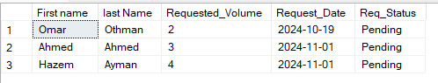
Querie 2:
Retrieve all fulfilled blood requests with their patient details.
Code:
SELECT BR.Request_ID , BR.Blood_Type, BR.Fulfillment_Date, P.Fname AS 'First name', P.Lname AS 'last Name'
FROM Blood_Request BR
JOIN Patient P ON BR.MR_Num = P.Medical_Record_Num
WHERE BR.Req_Status = 'Fulfilled';
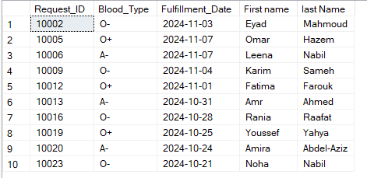
Querie 3:
Retrieve details of transfusion events for patients with a specific diagnosis.
Code:
SELECT Transfusion_ID, Transfusion_Date, Volume_Transfered_litres, Doctor_in_Charge
FROM Transfusion_Event
WHERE Medical_Record_Num IN (
SELECT Medical_Record_Number
FROM Patient_History
WHERE Diagnosis = 'Diabetes'
);
Querie 4:
how much blood is being requested by patients grouped by their blood type.

Code:
SELECT P.Blood_Type AS 'Blood Type', COUNT(B.Request_ID) AS 'Total Requests', SUM(B.Requested_Volume) AS 'Total Volume Requested (L)'
FROM Patient P JOIN Blood_Request B ON P.Medical_Record_Num = B.MR_Num
GROUP BY P.Blood_Type
ORDER BY SUM(B.Requested_Volume) DESC;
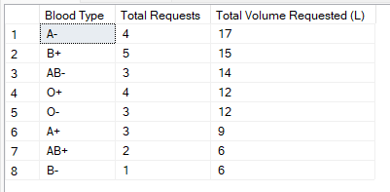
Querie 5:
list of patients along with their transfusion details. For patients who haven't undergone any transfusion, display their details with null values for transfusion information. This ensures all patients are accounted for, whether they have a transfusion record or not.
Code:
SELECT Fname AS 'First Name',Lname AS 'Last Name',Blood_Type , Transfusion_Date ,Volume_Transfered_litres ,Doctor_in_Charge
FROM Patient P LEFT OUTER JOIN Transfusion_Event T ON P.Medical_Record_Num = T.Medical_Record_Num
ORDER BY
P.Lname, P.Fname;
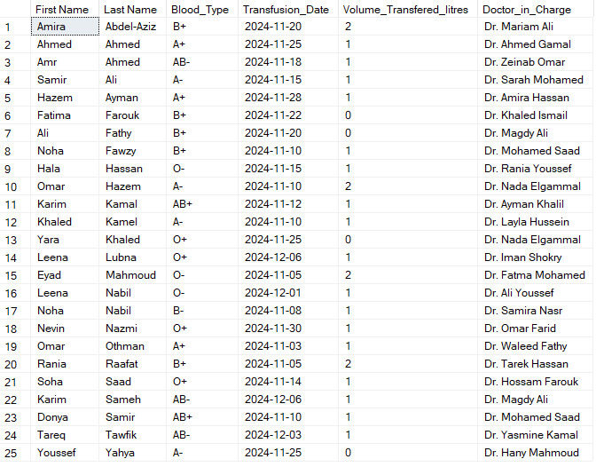

Sohaila245365
1. Nested Query
Scenario:
Retrieve the latest donation date for each donor as part of donor management efforts to identify individuals whose donations are becoming outdated. This query helps staff easily pinpoint donors who have not participated in recent donation drives, so they can be contacted with reminders or encouragement to donate again.

Code:
SELECT d.Donor_ID, d.Fname, d.Lname,
(SELECT MAX(Last_Donation_Date)
FROM Donor_History dh
WHERE dh.Donor_ID = d.Donor_ID)
AS Last_Donation_Date
FROM Donor d;

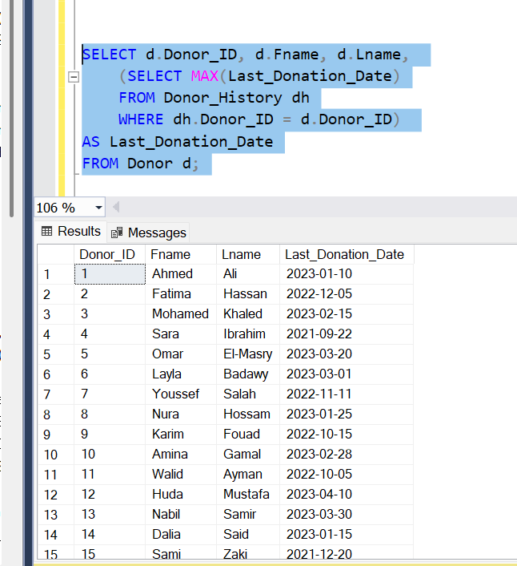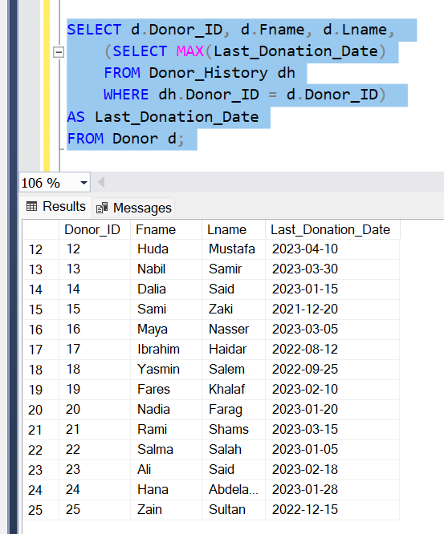

2. Aggregation Query

Scenario:
Retrieve the count of blood requests fulfilled and pending, grouped by blood type, to analyze blood request management effectiveness. This query helps track how many requests for each blood type have been completed (fulfilled) and how many are still pending.

Code:
SELECT Blood_Type, Req_Status, COUNT(*) AS Total_Requests
FROM Blood_Request
GROUP BY Blood_Type, Req_Status;

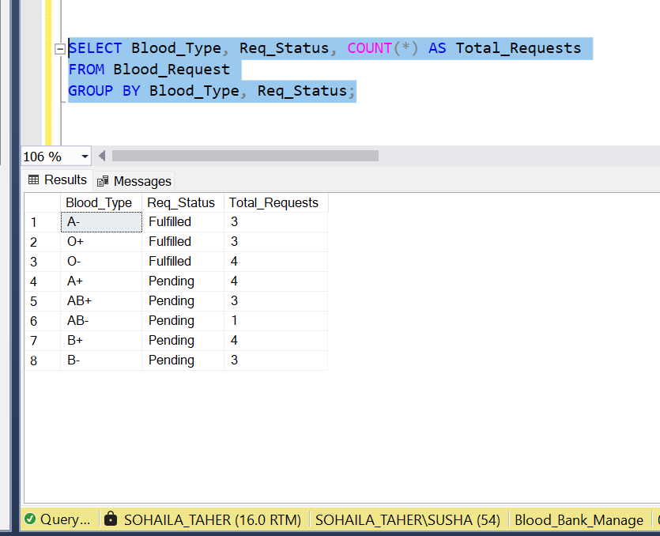

3. Left Join Query
Scenario:
Retrieve all donors along with their donation history, including those who have not made any donations. This query ensures that every donor is listed, whether they have donated or not, and provides their last donation date

Code:
SELECT d.Fname AS Donor_FirstName, d.Lname AS Donor_LastName, dh.Last_Donation_Date
FROM Donor d
LEFT JOIN Donor_History dh ON d.Donor_ID = dh.Donor_ID;

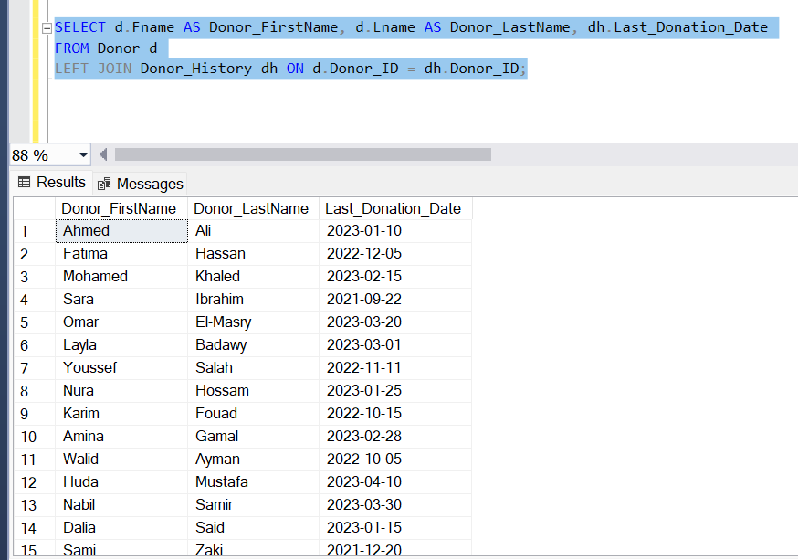
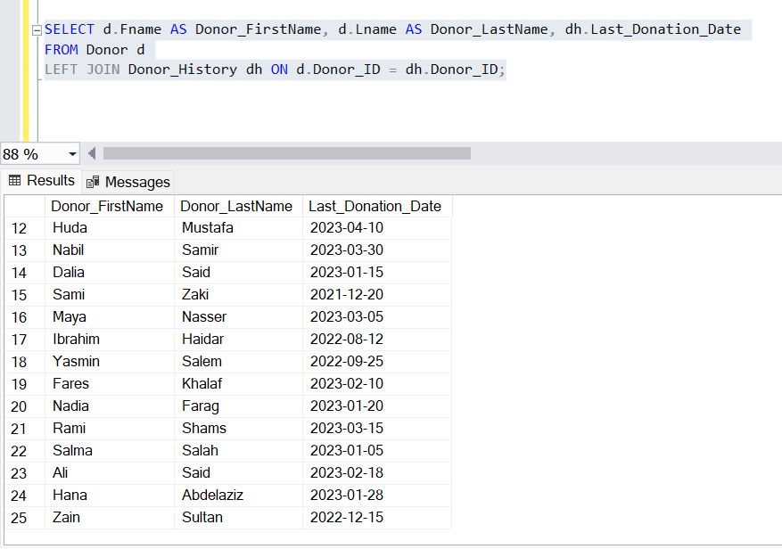

4. Inner Join Query
Scenario:
Retrieve all patients along with their blood request details, including the requested volume, blood type, request date, and request status. This query provides a detailed overview of each patient's blood request history.
Code:
SELECT
p.Fname AS Patient_FirstName,
p.Lname AS Patient_LastName,
br.Requested_Volume,
br.Blood_Type,
br.Request_Date,
br.Req_Status
FROM
Patient p
INNER JOIN
Blood_Request br ON p.Medical_Record_Num = br.MR_Num;
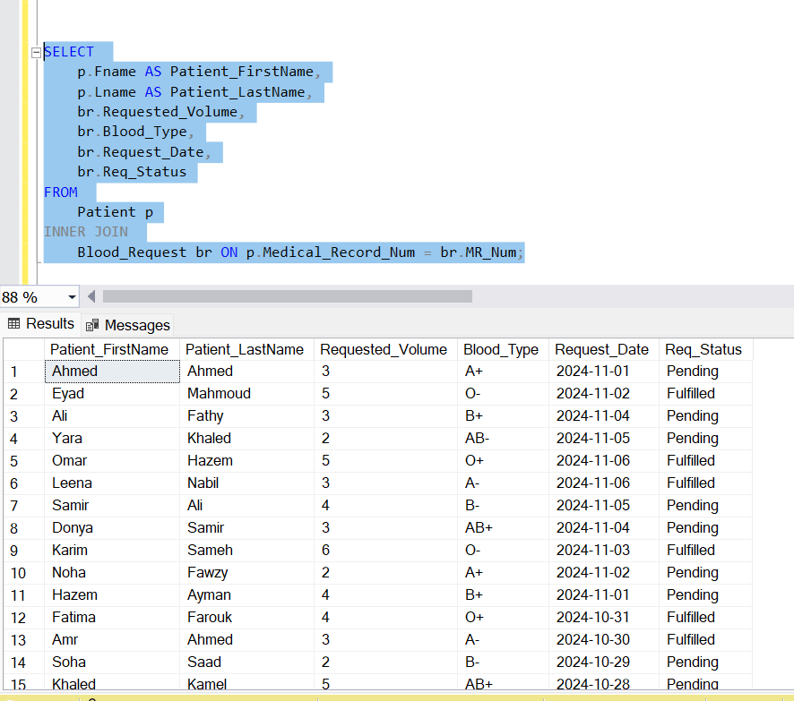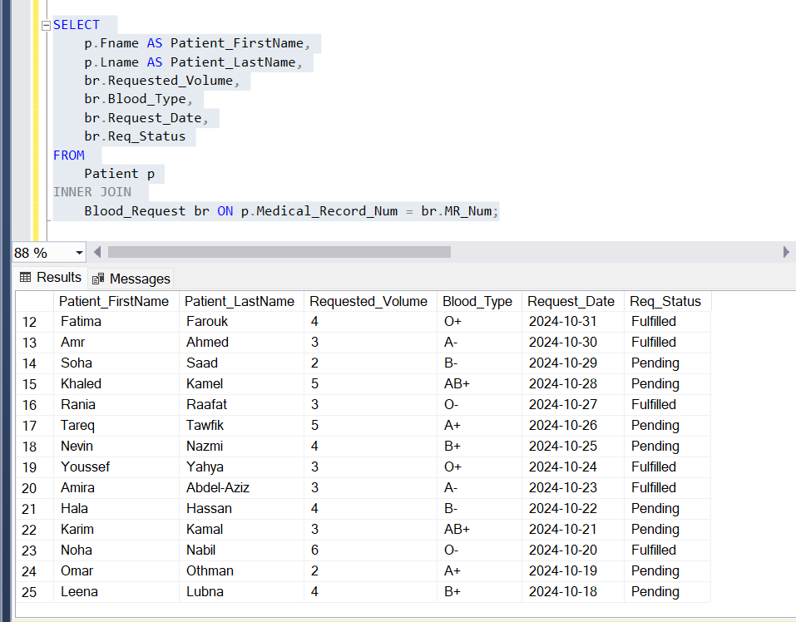

5. Simple Query
Scenario:
Retrieve each donor's ID, full name, and age (calculated from their date of birth).
Code:
SELECT Donor.Fname + ' '+ Donor.Lname AS Name, Donor_ID,
DATEDIFF(YEAR, Date_of_Birth, GETDATE()) AS Age
FROM Donor;

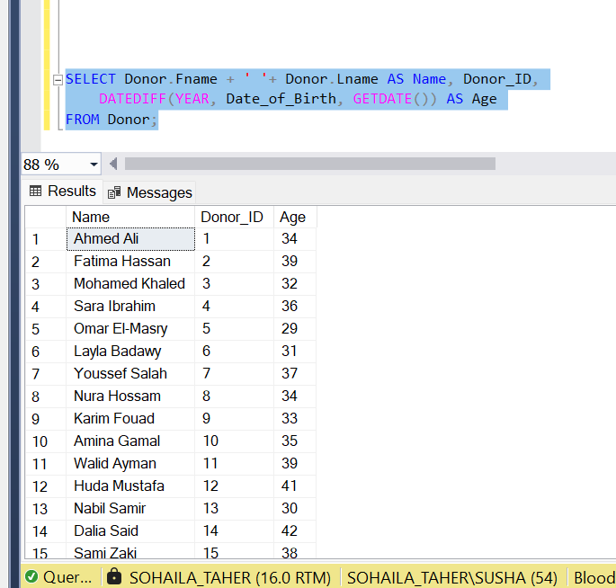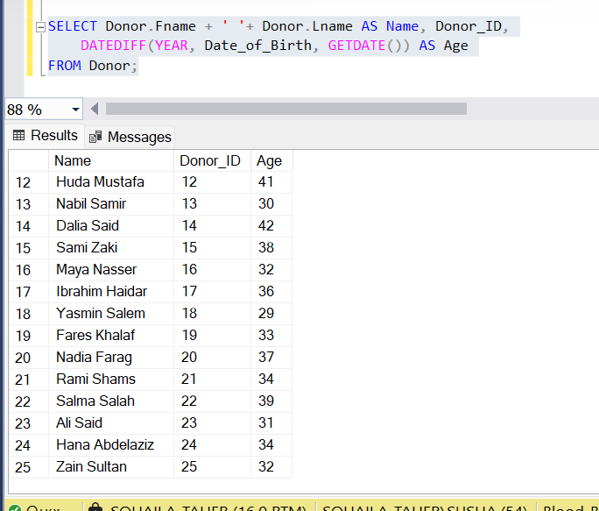

Shahd247915
- SELECT E.Fname, E.Lname
FROM Employee E
WHERE E.Blood_Bank_ID = (
SELECT B.ID
FROM Blood_Bank B
WHERE B.City = 'Cairo'
);

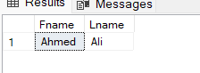

- SELECT H.Hospital_ID, H.Name AS Hospital_Name, H.City AS Hospital_City, H.Street, H.Zip_code, B.Bank_Name, B.City AS Blood_Bank_City, B.Contact_Number
FROM Hospital H
JOIN Blood_Bank B ON H.Blood_Bank_ID = B.ID;

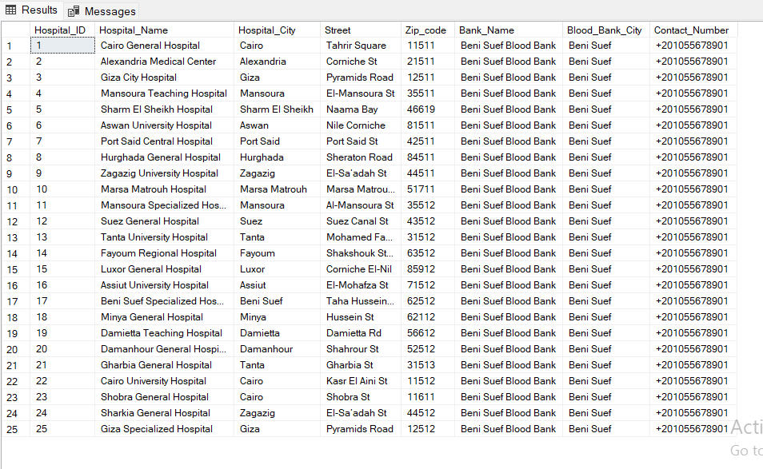

- SELECT B.Bank_Name, COUNT(E.Ssn) AS Employee_Count
FROM Blood_Bank B
LEFT JOIN Employee E ON B.ID = E.Blood_Bank_ID
GROUP BY B.Bank_Name;

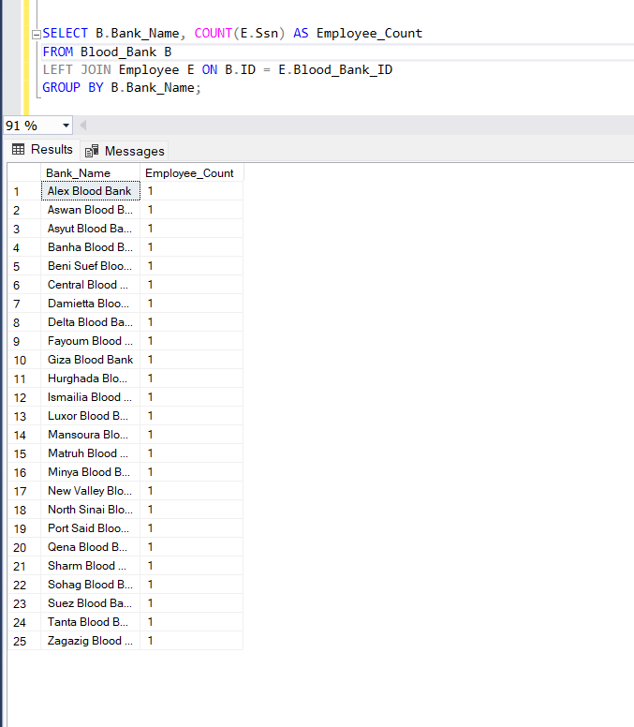

- SELECT COUNT(*) AS Total_Blood_Banks
FROM Blood_Bank;
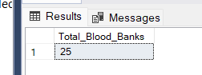

- SELECT COUNT(*) AS Total_Blood_Banks
FROM Blood_Bank;

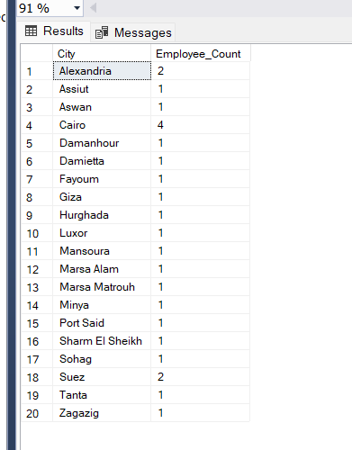

- SELECT H.Name AS Hospital_Name, B.Bank_Name AS Blood_Bank_Name
FROM Hospital H, Blood_Bank B
WHERE H.Blood_Bank_ID = B.ID;

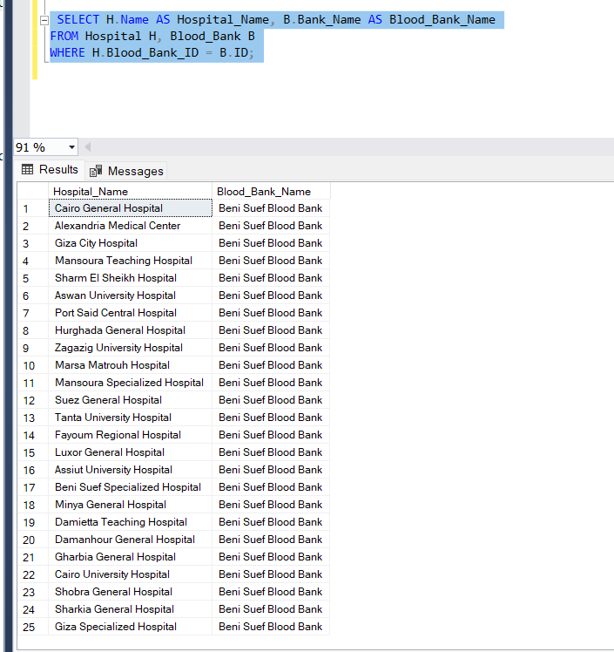

Abdelrahman shehta 243700:
Donations with health statues excellent:
SELECT Donation_ID, donation.Vloume_Donated, Health_Status
FROM Donation
WHERE Health_Status = 'Excellent';
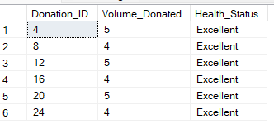

Retrieve the sum of the donated volume of each Donor:
SELECT Fname+' '+ Lname AS 'Full_Name' , SUM(Vloume_Donated) AS 'Total_Volume'
FROM Donor JOIN Donation ON Donor_ID = Donation_ID
GROUP BY Fname, Lname;
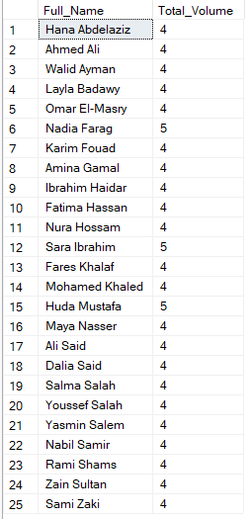

Retrieve the Blood type and volume donated in a specific date
SELECT Fname, Lname, Donation.Blood_Type,Vloume_Donated,Donation_Date
FROM Donor JOIN Donation ON Donor_ID = Donation_ID;
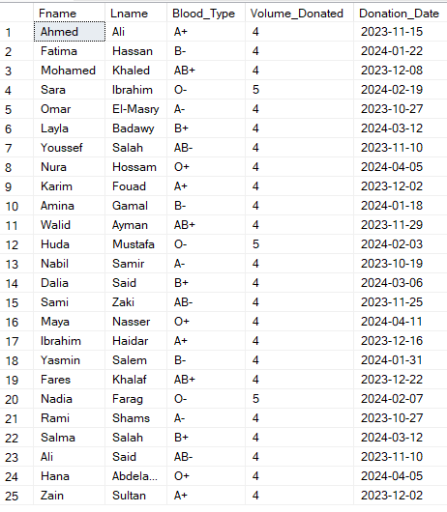

Retrieve Average volume donated from Donation
SELECT AVG(Vloume_Donated) AS Avg_Blood_Donated
FROM Donation;
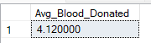

Get the name of donors and their donation volumes and using left and right outer join:
SELECT Fname,Lname, Vloume_Donated
FROM Donor left outer JOIN Makes ON Donor.Donor_ID = Makes.Donor_ID right outer JOIN Donation
ON Makes.Donation_ID = Donation.Donation_ID;

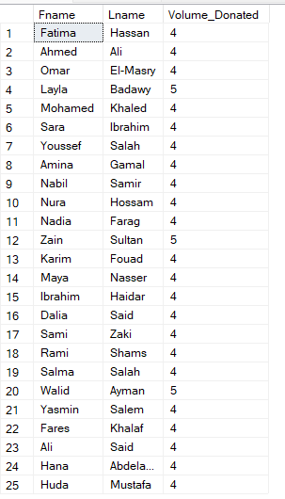

Donors donated in year 2024 :
SELECT Fname, Lname, Address
FROM Donor WHERE Donor_ID
IN ( SELECT Donor_ID FROM Makes WHERE Donation_ID IN ( SELECT Donation_ID FROM Donation WHERE Donation_Date between '2024-1-1' and '2024-12-30' ) );

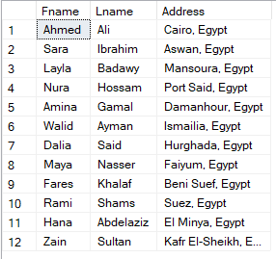

Omayr ali : 242994

1. Get Blood Banks with Donors having "Excellent" Health Status:
SELECT Bank_Name, City
FROM Blood_Bank
WHERE ID IN (
SELECT Blood_Bank_ID
FROM Donation
WHERE Health_Status = 'Excellent'
);
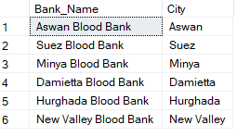

2. Storage facilities that have less than 30 units of blood stored:
SELECT Storage_Facility.Storage_ID, SUM(Stored_Blood_Quantity) AS 'Total_Blood'
FROM Storage_Facility JOIN Blood_Inventory
ON Storage_Facility.Storage_ID = Blood_Inventory.Storage_ID
GROUP BY Storage_Facility.Storage_ID
HAVING SUM(Stored_Blood_Quantity) < 30
ORDER BY 'Total_Blood';
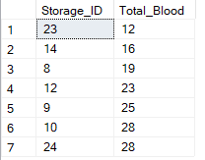

3. Calculate the expiry date of blood units stored in the storage facility:
SELECT Inv_ID, DATEADD(day, Validity_Period, Date_Stored) AS 'Expiry Date'
FROM Blood_Inventory
ORDER BY 'Expiry Date';
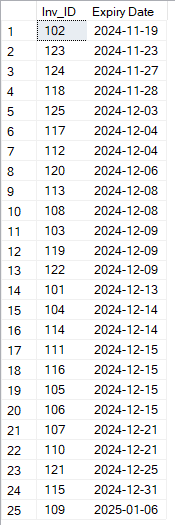

4. Find Storage Facilities with No Blood Inventory:
SELECT Storage_Facility.Storage_ID, Storage_Facility.Facility_Type, Storage_Facility.Capacity, Storage_Facility.City
FROM Storage_Facility LEFT JOIN Blood_Inventory
ON Storage_Facility.Storage_ID = Blood_Inventory.Storage_ID
WHERE Blood_Inventory.Storage_ID IS NULL
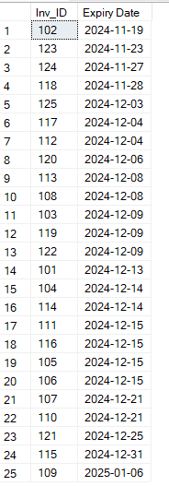

5. Retrieve storage facilities with capacity greater than 700:
SELECT Storage_ID, City, Street, Postal_Code, Capacity
FROM Storage_Facility
WHERE Capacity > 700
ORDER BY Capacity DESC;
